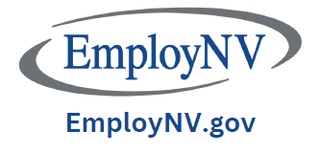

Rural EmployNV Hubs
Where are we located?
- Elko – 172 6th Street / 775-753-1900
- Ely – 1500 Avenue F, Suite 1 / 775-289-1616
- Fallon – 121 Industrial Way / 775-423-5115
- Winnemucca – 475 West Haskell Street #1 / 775-623-6520
- Fernley – 1320 West Newlands Drive / 775-439-3077

Services:

  - Job listings and searches for job seekers.

  - Resume assistance and mock interviews.

  - Training assistance and items needed for employment. The Career Enhancement Program can possibly pay for both short term and extended training and items needed for employment (work boots, bar cards, gaming cards, scrubs and non-slip shoes as examples).

  - Veterans Representative (Fallon and Elko). Virtual appointments or local visits possible for veterans in other rural areas.

  - Vocational Rehabilitation.

  - Business Account Managers located in Fernley and Elko. Employers can contact these individuals for assistance in posting jobs and programs geared towards employers.

