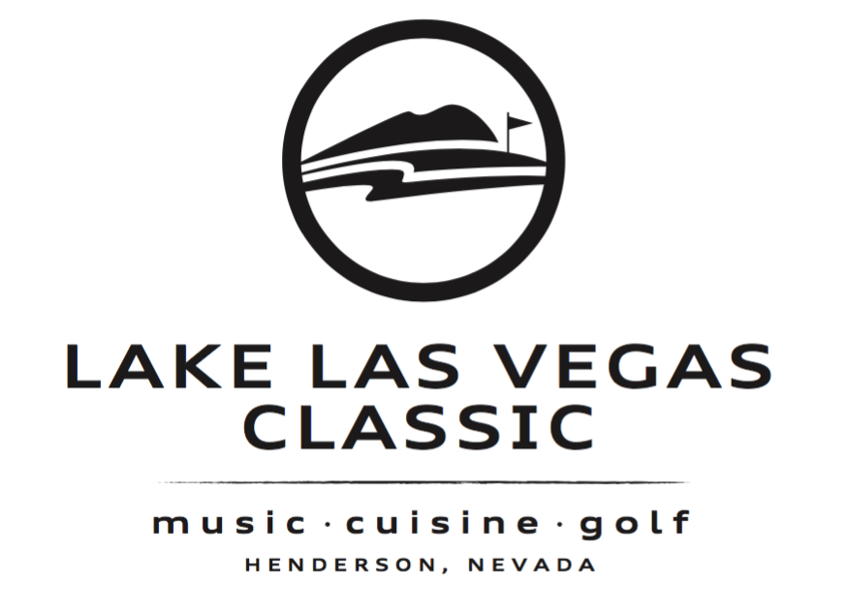
Travel Nevada - Presenting Sponsorship Proposal

Event Dates & Location:
October 26th, 27th & 28th, 2017 – Reflection Bay Golf Club – Lake Las Vegas

Advertising Included in Package:
- Full page ad in the 2018 edition of Golfing Oregon Magazine – Value of $4000
- Full page ad in the 2017/18 edition of Golfing Southern California Magazine – Value of $4000.
- Full page ad in the 2017/18 edition of Golfing Palm Springs Magazine – Value of $4000.
- (6) Email blasts to our opt in database of over 75,000 subscribers spread throughout the Western United States – Value of $3300

Event Exposure Included in Package:
- Listing as a Presenting Sponsor in all event media and event signage. Joining other Presenting Sponsors that include City of Henderson, Topgolf, Southern Glazers, Blue Heron, Lake Las Vegas, NBC, Beasley Media and more.
- (2) Golf Teams in the tournament on Friday (8 players)
- (40) Individual dinner tickets to The Feast.
- (16) Entries into the Thursday night VIP Launch Party at Topgolf Las Vegas.
- (1) Full page ad in the official event program.
- (1) Hole sponsorship during the golf tournament and the ability to staff the hole during the golf tournament.
- Inclusion in all advertising promoting the event on television, print, radio and more. Over $300,000 in marketing supporting the event.
- Ability to place one sheets/brochures in each golfer gift bag
- Recognition in the event program as a Presenting Sponsor, Corporate Team Sponsor, Hole Sponsor and Corporate Table Sponsor.
- Logo and name mentions in and on all print/radio/tv advertising including event posters (200), check stuffers at restaurants (800), promotions, website and more.
- Rotating website banner ad on the event website, 300x250.

IN RETURN FOR ITS SPONSORSHIP BENEFITS, Travel Nevada WILL PROVIDE THE FOLLOWING:

- $10,000 cash investment in the event

